Emily Coffer

PRHM 828

Case Study #2

December 1, 2017

At this time, quality metrics for pharmaceutical manufacturers are not readily available to the everyday consumer or potential buyers. My research group was tasked with finding an alternative method for ranking pharmaceutical manufactures of the drug simvastatin by creating and defining elements of a scorecard. To accomplish this, it was important to define quality, scorecard, quality scorecard and each element used on the scorecard. Quality was defined as a standard measure of conformity to a set of regulation, safety, and efficacy guidelines that includes the efficiency of the manufacturing process and pharmaceutical distribution. A scorecard was defined as a performance management tool that can be used to monitor and maintain the highest quality drug. A pharmaceutical scorecard should encompass a manufacturer’s economics, consumer compliance, internal processes, leadership and ability to innovate. A quality scorecard was defined as a quality assurance performance management tool that can be used to monitor the efficacy and safety of a distributed drug.

In order to create a quality scorecard, quality elements of a manufacturer needed to be chosen and defined. My research group determined measureable quality elements for our scorecard to include the number of manufacturing recalls, the number of FDA warning letters, the number of FDA 483 observations, the number of consumer complaints, the average wholesale price (AWP) unit price, and the number of excipients added to the active ingredient. The number of recalls was defined as a manufacturer’s actions to remove a drug from the commercial market that is substandard or potentially harmful to the targeted population. The FDA warning letters are notifications sent to manufacturers that have significantly violated an FDA regulation. An FDA letter can be issued during a site visit if manufacturing practices are incredibly poor or post-site visit if a manufacturer continues to be non-compliant after being issued multiple FDA 483 citations. FDA 483 citations are issued upon observable infractions of deficient equipment or facility failures during an on-site visit by an FDA representative. Consumer complaints were defined as the number of reported adverse reactions to the manufacturers drug product. The average wholesale (AWP) unit price was found for a 30-day supply of a 20-milligram dose of simvastatin. The number of excipients were determined to be the number of inactive ingredients added to a tablet of simvastatin. The higher the number of excipients a manufacturer used, the higher the probability for adverse drug reactions to occur in our target population.

In order to define and acquire the necessary quality element values, an extensive online web search was performed. To determine the manufacturers of simvastatin, the FDA Approved Drugs Database was used with a specific search for simvastatin. My research group used reliable and accredited sources such as Google Scholar to formulate appropriate definitions for our scorecard. To minimize our search, words such as “scorecard” AND “pharmaceuticals were employed to specify elements related only to medications and eliminate any extraneous definitions that might not coincide with our desired results. To determine the number of FDA recalls, the FDA Inspections Database and Achieves was used to search for manufacturers of simvastatin and then within a manufacturer’s listing of recalls, observe only recalls associated with simvastatin. The only company that yielded a simvastatin recall was Biocon Pharmaceuticals that had a Class III recall due to manufacturing simvastatin dosage forms with sub-potent levels of simvastatin active ingredient. To determine the number of FDA warning letters, the FDA Electronic Reading Room for Warning Letters was utilized by searching for each manufacturer. The number of FDA warning letters received by a manufacturer within the last 5 years were included in the total number of warning letters. To determine the FDA 483 observations, the FDA inspection database was utilized to manually search for violations of FDA regulations by individual manufacturer. This required the use of the find function within Microsoft Excel to locate each manufacturer of simvastatin; however, violations that occurred more than 5 years ago were not included in the total number of violations. To determine consumer complaints, the FDA Adverse Event Reporting System (FAERS) dashboard was used to search specifically for simvastatin. The number of adverse events could be determined by switching the dashboard view to list all reported adverse events. To minimize the number of cases, the suspected product or active ingredient was limited to only simvastatin and the date on which the adverse event occurred had to have happened within 2017. The manufacturer control number was used to identify our specific manufacturers and the corresponding number of adverse events was counted manually. For the manufacturers IVAX and Watson Laboratory, since they are both subsidiaries of TEVA, consumer complaints were divided evenly between the two. For manufacturers whose names were not explicitly listed within a corresponding manufacturer control number (HISUN and VIVA), an estimate the number of adverse events. The number of excipients each manufacturer added to their dosage form was determined by searching the DailyMed Database from the U.S. National Library of Medicine. A manufacturer’s name and simvastatin were entered into the database to yield the dosage forms ingredients and appearance, where the excipients added were listed. The average wholesale unit price was determined by using RedBook from the Micromedex Database. Simvastatin was entered into Redbook and the 30-day supply of 20 mg tablets for each manufacturer was recorded.

Each of these quality elements were ranked in order of deemed severity and how negatively it reflected on the manufacturer. The quality elements were ranked as follows: drug recalls, FDA warning letters, FDA 483 observations, average wholesale unit price, the number of excipients and, consumer complaints. Each of the quality elements is associated with a point value that will be used to determine the quality of the manufacturer. The ranking of the quality elements corresponds to the most severe to least, and thus drug recalls is associated with the highest point value and the number of consumer complaints corresponds to the lowest point. The lowest scorecard point total is associated with the highest quality manufacturer. The number of recalls is multiplied by 5 points per recall. The number of FDA warning letters is multiplied by 3 points per warning letter. The number of FDA 483 observations is multiplied by 0.5 points per citation. The amount of excipients is calculated by adding 0.5 points for each number of excipients above the average of 12. The average wholesale unit price is calculated by adding 0.5 points for each $0.02 above the average price of $4.89. The point values per quality element observations can be observed in the table below.

|  |  |
| --- | --- |
| Quality Element | Point Value |
| Recalls | 5 |
| FDA Warning Letters | 3 |
| FDA 483 Observations | 0.5 |
| AWP Unit Price | 0.5 |
| Number of Excipients | 0.5 |
| Consumer Complaints | 0.25 |

Table 1: Quality Scorecard Point Association

The results of these calculations can be observed in the table below, contained within my research group’s quality scorecard.

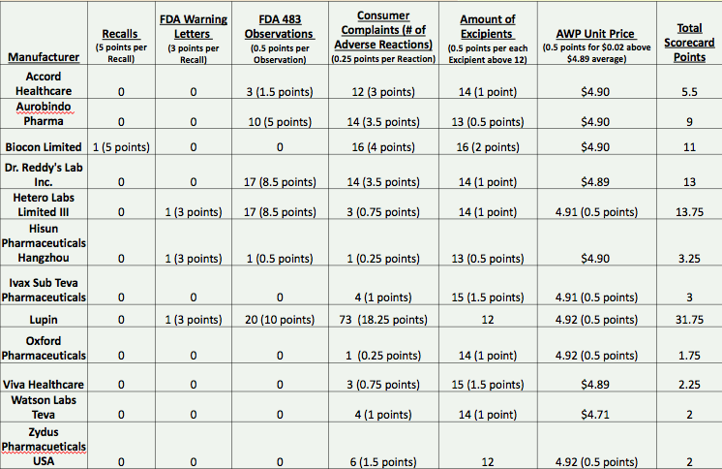

Table 2: Quality Scorecard for Simvastatin Manufacturers

Based on the point totals in the scorecard, the highest quality manufacturer was determined to be Oxford Pharmaceuticals. The remaining manufacturers are ranked as follows: Watson Labs (subsidiary of TEVA Pharmaceuticals), Zydus Pharmaceuticals, Viva Healthcare, IVAX (subsidiary of TEVA Pharmaceuticals), Hisun Pharmaceuticals, Accord Healthcare, Aurobindo Pharmaceuticals, Biocon Limited, Dr. Reddy’s Laboratory Inc., Hetero Laboratory Limited, and Lupin Pharmaceuticals.

References:

1 Affairs, O. O. (n.d.). Inspection References - Inspections Database. Retrieved November 30, 2017, from <https://www.fda.gov/ICECI/Inspections/ucm222557.htm>

2 Center for Drug Evaluation and Research. (n.d.). Drug Recalls. Retrieved November 30, 2017, from <https://www.fda.gov/Drugs/DrugSafety/DrugRecalls/default.htm>

3 DailyMed. (n.d.). Retrieved November 29, 2017, from <https://dailymed.nlm.nih.gov/dailymed/index.cfm>

4 Drugs@FDA: FDA Approved Drug Products. (n.d.). Retrieved November 29, 2017, from <https://www.accessdata.fda.gov/scripts/cder/daf/>

5 Enforcement Report. (n.d.). Retrieved November 30, 2017, from <https://www.accessdata.fda.gov/scripts/ires/index.cfm>

6 FDA's Electronic Reading Room - Warning Letters. (n.d.). Retrieved November 29, 2017, from <https://www.accessdata.fda.gov/scripts/warningletters/wlSearchResult.cfm?firstChar=H&displayAll=false&page=2>

7 Results: Inspection Classification Database Search. (n.d.). Retrieved November 30, 2017, from <https://www.accessdata.fda.gov/scripts/inspsearch/results.cfm>

8 Simvastatin. (2015, January 22). Retrieved November 30, 2017, from <https://www.healthline.com/health/simvastatin/oral-tablet>

9 Use of the Balanced Scorecard to Improve the Quality of Behavioral Health Care. (n.d.). Retrieved November 30, 2017, from <https://ps.psychiatryonline.org/doi/abs/10.1176/ps.50.12.1571>

10 U.S. Food & Drug Administration. Inspection Database. Available at:<https://www.fda.gov/ICECI/Inspections>.  Accessed November 28, 2017.

11 U.S. Food & Drug Administration. FDA Adverse Events Reporting System (FAERS). Available at:<https://fis.fda.gov/sense/app/777e9f4d-0cf8-448e-8068-f564c31baa25/sheet/7a47a261-d58b-4203-a8aa-6d3021737452/state/analysis>. Accessed November 28, 2017.

12 U.S. Food & Drug Administration. Quality Metrics - FDA Public Meeting. Available at: <https://www.fda.gov/downloads/Drugs/NewsEvents/UCM459844.pdf>. Accessed November 28, 2017.

13 US FDA Form 483 and Warning Letter Analysis, Response, and Recovery. (2017, June 28). Retrieved November 30, 2017, from <https://www.emergogroup.com/services/united-states/fda-483-consulting>